

Upper Tribunal
Immigration and Asylum Chamber Appeal Numbers: IA/41375/2014

IA/41380/2014

IA/41383/2014

THE IMMIGRATION ACTS

Heard at Field House | Decision & Reasons Promulgated
On 8 October 2015 | On 19 November 2015

Before

UPPER TRIBUNAL JUDGE PERKINS
UPPER TRIBUNAL JUDGE S H STOREY

Between:

1) O s
2) j s
3) p s

Appellants
and

SECRETARY OF STATE FOR THE HOME DEPARTMENT

Respondent

Representation:

For the Appellant: Mr E Tufan, Home Office Presenting Officer
For the Respondent: Mr Aborinsade, OA Solicitors

DECISION AND REASONS

Background
- This is an appeal made by the above Appellants against the decision of the First-tier Tribunal (FTT) dated 15 May 2015, dismissing the Appellants’ appeals against the decision of the Secretary of State (the Respondent) dated 6 October 2014, in which she refused the Appellants’ application for further leave to remain.
- The Appellants are all nationals of Nigeria. The first and second Appellants arrived in the UK with entry clearance as visitors. A subsequent application for leave as a visitor was refused on 26 November 2008. The first and second Appellants have overstayed the period of their lawful leave. The third Appellant was born in the UK on 11 October 2010 but has never had leave to enter or remain in the UK.
- On 22 August 2012, the family applied for leave to remain in the UK under paragraph 276ADE of the Immigration Rules and Articles 3 and 8 of the ECHR, and section 55 of the Borders, Citizenship and Immigration Act 2009 (the BCIA 2009). The crux of the third Appellant’s application was that he suffers was sickle cell disease, a life threatening condition for which inadequate treatment is available in Nigeria. As such, requiring him to return to Nigeria was inhuman or degrading treatment contrary to Article 3 as it posed risks to his health and his life. In support of the application, the Appellant submitted medical evidence, in particular, the documents appearing at pages 20 – 24 of the bundle produced before us. This evidence together with additional documentation was before the Respondent and the FTT.

The FTT’s decision
- The FTT heard the Appellants’ appeals on 20 April 2015 and promulgated the decision and reasons on 18 May 2015.
- The judge stated that the Appellants’ application for leave to remain was made outside of the immigration rules. That may explain, why he failed to address the Immigration Rules, specifically Appendix FM (Family Life) and Rule 276ADE (Private Life); Articles 3 and 8 ECHR, which, along with section 55, were all given consideration by the Respondent in her comprehensive 10.5 page decision. By contrast, the FTT decision was a page and a half in length with findings of fact limited to twelve lines.
- In the application for permission dated 26 May 2015, the Appellants submit that the FTT decision is erroneous in law because the judge:
      - misdirected himself in law;
      - made inadequate findings of fact;
      - failed to provide adequate reasons;
      - failed to take relevant matters into consideration; and
      - reached unreasonable conclusions.
- I will return to these grounds later as far as this is necessary.

Proceedings before the Upper Tribunal
- At the hearing before us, Mr Aborisade, for the Appellants, submitted that the FTT judge had failed to give anxious scrutiny to the medical evidence which he said suggested that 50% of children with sickle cell disease in Nigeria die before the age of 10 years owing to lack of adequate treatment. He considered that there were significant obstacles to reintegration of the family into Nigeria as a result of the third Appellant’s medical condition, the length of residence in the UK of the family and the impact on the children’s education as well as other factors. He maintained that the evidence before the FTT demonstrated that exceptional circumstances existed but that the FTT judge failed to conduct a balancing exercise and compounded his error by failing to provide adequate reasons for the decision.
- Mr Tufan, for the Respondent, submitted that sickle cell anaemia is a common disease in Nigeria for which treatment is readily available. He said that it was not a life threatening condition and hence the Appellants’ circumstances were not exceptional. He submitted that the medical evidence was unreliable because the report (documents 22 – 25) did not explain the source of the statistics quoted. Whilst conceding that the FTT judge did not fully consider the evidence before him, or address the discrepancies in the evidence, Mr. Tufan nevertheless maintained that the FTT decision did not disclose a material error of law.

Was there an error of law?
- The FTT judge was required to make clear findings of fact setting out what evidence he accepted; what evidence he rejected; whether there was any evidence, on which he was undecided; and what, if any, evidence he regarded as irrelevant. Furthermore, where the FTT had before it medical or other expert evidence, it was required to give reasons for accepting or rejecting the evidence. None of thee things was done by the FTT judge. His one and a half page decision was devoid of any consideration of the Immigration Rules, Appendix FM (Family Life) and Rule 276ADE (Private Life), Articles 3 and 8 of the ECHR, the duty under section 55 of the BCIA 2009 and the medical evidence relating to the third Appellant. Whilst short reasons can be perfectly adequate, the brevity of this decision demonstrates a lack of anxious scrutiny and a failure to give consideration to relevant factors as required by law.

Decision
- For all the above reasons, we are unable to accept the submissions of the Secretary of State’s representative that the FTT has made adequate findings of fact and given sufficient reasons for its decision. We therefore set aside the decision of the FTT for error of law and remit the case for rehearing by a new tribunal. The effect of this decision is that a new tribunal will now hear the appeal. It is their responsibility to evaluate the evidence and to reach a decision on an assessment of that evidence, applying the relevant law.
- The Appellants should note that the fact this appeal has succeeded before the UTIAC is not an indication of the likely outcome before the new tribunal.

Signed: | Dated:
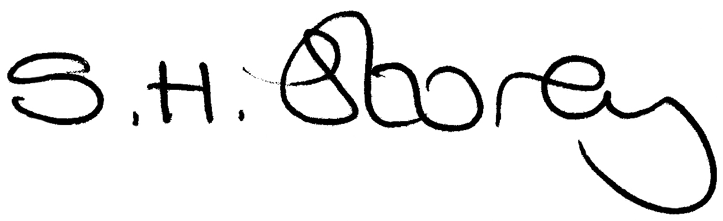  Sehba H Storey  Judge of the Upper Tribunal | 10 November 2015

